Cartooning & Anatomy

Community Partner/Site: HGMS
Age of Students: 6 th-8th
Dates: Fall 2018

Days: Tuesdays and Thursdays
Time: 90 min classes

PROJECTS:
Skeleton and muscle drawings
Character diagrams
Maquette-figure sculptures
Action books
Final projects (students’ choice: comic book zines or large comic book covers)

Class 1:
Introductions and community agreement
Apprenticeship outline
Human proportions
Class expectations

Class 2
Large skeleton drawings

Class 3
Continue large skeleton drawings
Begin musculature layer drawings

Class 4
Finish skeleton and musculature drawings

Class 5
Sculpting Figures - Skeletal framework, armature wire

Class 6
Sculpting Figures - Skeletal framework, armature wire

Class 7
Sculpting Figures - Muscles using white air dry clay

Class 8
Sculpting Figures - Muscles using white air dry clay

Class 9
Start character diagrams

Class 10
Character diagrams - complete
Exit ticket: Choose your final project

Class 11
Action Books - drawing from the maquette
Sketches for book

Class 12
Action books
Drawings from sketches, lay out book

Class 13
Action books - Add color

Class 14
Color theory
Final projects - Begin sketches

Class 15
Final projects - Refine and transfer

Class 16
Final projects - Add color
Artist statement notes in sketchbook

Class 17
Final projects - Add color
Artist statement writing

Class 18
Final projects - Complete.
Final critique

Class 19
Select works for culminating event
Culminating event practice

Class 20
Culminating event
Additional projects can include:
-1 page zine -character’s origin story
-Mini-comics 4.25 x 5.5” - 2D materials of TA choice.

CARTOONING & ANATOMY

CLASS 1: Human Proportions

Unit theme: How do comic book artists and illustrators use art to tell a story? How will I use different techniques and materials to create lifelike artwork that tells a story?

Title: Human Proportions

Time: 1 85-minute class (4:15pm - 5:40pm)

Learner Objectives:
SWBAT
• develop an understanding for human proportions
• develop courage as they work with new media and practice basic measurement and drawing skills; the comfort they develop with general body structure will allow them to comfortably take risks later on in the program.

Student Outcome
Students will create charcoal drawings of the simplified human body in order to explore and begin to understand basic proportions. Vine charcoal on paper.

Introduction:
TA will guide students through an exquisite corpse warm-up activity to set a playful, low-stakes tone for the class.

Materials:
Poster paper, markers, 8.5x11 or 8.5x14 printer paper, pencils, erasers, newsprint, vine charcoal, human proportions handout, plastic bags, portfolios.

Vocabulary:
- Anatomy: the structure of the body, or how a body is set up or arranged
- Proportions: comparative measurements of parts of a whole, or figuring out the size of something by comparing it to something else
- Pose: a particular way of standing or sitting

CLASS 1

Lesson Element | Time | Activity
Introduction | 2 min  10  5 | 1. Welcome  Students enter the classroom and find their seats. TF and TA help students get seated and quiet quickly and efficiently.  2. Introductions  Teaching artist, TF, and students will introduce themselves. To break the ice, everyone will share their name, grade or age, and the superpower they would most like to have.  3. Community agreement  TA will facilitate a discussion of community norms for the semester. These will include but are not limited to (1) one mic, (2) treat classmates, staff, and materials with respect, and (3) there are no mistakes in art -- only happy accidents! Students will be encouraged to add their own ideas to the agreement, which will be written down as a poster and kept up for the duration of the program. TF will help keep students focused and engaged.
Demonstration
Work Period | 15  5  8  30 | 4. Exquisite corpse warm-up activity  TF will help students organize themselves into groups of three while TA explains the exquisite corpse drawing game. Using sheets of printer paper and pencils, students will collaboratively create silly, fantastical characters. Students who draw quickly should be encouraged to see how many details they can add to their portion of the drawing.  a. Fold the sheet of paper into thirds.  b. On the top third of the paper, draw the head of a character. Be sure to extend the lines of the neck down past the fold, and then turn the paper so the head you’ve drawn is no longer visible and all the next person can see are the lines of the neck on the middle third of the paper.  c. Pass the paper to your right, and on the new sheet of paper you’ve received, draw a torso (have a student explain what part of the body the “torso” is). No peeking at the head! When you’re done with your drawing, extend the lines down to the bottom third of the paper and fold it again.  d. Pass the paper to your right, and on the bottom third of the paper, draw legs and feet (or flippers, roller blades, a hoverboard, etc.).  e. Unfold the paper! Spend a couple of minutes discussing the drawings with your group.  5. Apprenticeship outline and syllabus review  TA will review the plan for the Cartooning & Anatomy apprenticeship including major projects and WOW performance task. TF will help keep students focused and engaged.  6. Material exploration with charcoal  TA will demo some techniques with charcoal including making dark lines, light marks, and smudging as TF passes out charcoal and newsprint paper. Students will be encouraged to see how many different kinds of marks they can make in order to fill up a sheet of paper.  7. Human proportions worksheet  TA and TF will pass out handouts while students get ready with a fresh sheet of newsprint and stick of charcoal. Students will follow along and draw as TA demos measuring basic human proportions on large sheet of paper. TF will circulate and keep students on task.  a. Measure out 8 lines on your paper, and number them from top to bottom.  b. Begin by drawing the head, with the chin resting on line 1.  c. Draw an oval between lines 3 and 4; it should be about as wide as the head is tall. Connect the head and pelvis.  d. Draw a horizontal line between 1 and two for the shoulders.  e. Fill in a tall semicircle from the middle of the shoulders down to halfway between lines 2 and 3.  f. Draw a circle on each end of the shoulder line, and then draw vertical lines from those circles down to line 3.  g. Ovals (elbows) should rest on top of line 3, and then the lower arm should extend down to line 4; this is where the wrists go, with the hands below them.  h. Draw two small circles on the outside of the pelvis resting on line 4, and draw two circles directly below them on line 6. Then, draw two more circles directly below them on line 8.  i. Connect the outside of the hips with the inside of the knees, and the outside of the knees with the inside of the ankles.  j. Add feet sticking out from the ankles, and you’re done!  k. If students finish their diagrams early, they should try to draw the figure in new poses (e.g. standing with arms out, crossing a leg over the other, etc.) keeping proportions consistent and accurate.
Clean Up |  | Charcoal, pencils, and erasers should be in plastic bags with students’ names written on them. Drawings and handouts should be in portfolios. Unused materials should be piled up and placed to the side. Tables that have gotten messy with charcoal dust should be wiped off. TA and TF will circulate to keep students on task.
Wrap Up | 4 min  1 min | Student expectations/wishes  TA will facilitate group conversation about what students are hoping to get out of this apprenticeship, and record suggestions on large paper. TF will help keep students focused and engaged.  Dismissal  Students gather belongings and are dismissed by TF.

Reflection: TA and TF will circulate throughout the work periods to check in on students’ progress. Possible questions to ask include:
- What did you think about working with the charcoal?
- How is it different from drawing with a pencil or pen?
- What is something that surprised you about the proportions of the human body?
- Do you feel ready to work on a more detailed drawing next week, or is there anything you think you might get hung up on?

Differentiation/Adaptations: Students will be allowed to move around the room while they are working with charcoal and on their proportions worksheets if they are more comfortable working on the floor, standing up, etc. Students will be asked to try using charcoal for this first class, but if anyone has a particular difficulty with getting messy they will be allowed to go back to pencil next week. TF will let TA know ahead of time if any students have additional special needs which might not be sufficiently addressed with either of these strategies.

Assessment:
- Did the student participate during group conversations, either by raising their hands and sharing their thoughts or by paying attention and engaging with the class (e.g. looking at the speaker, remaining quiet while others were speaking)?
- Did the student make an effort to experiment with the charcoal? Did they fill at least one sheet of paper with marks?
- Did the student follow along with the human proportions worksheet to create their own diagram?
- Did the student clean up their workspace to a satisfactory degree (materials in plastic bag, papers in portfolio, any trash in trash can)?

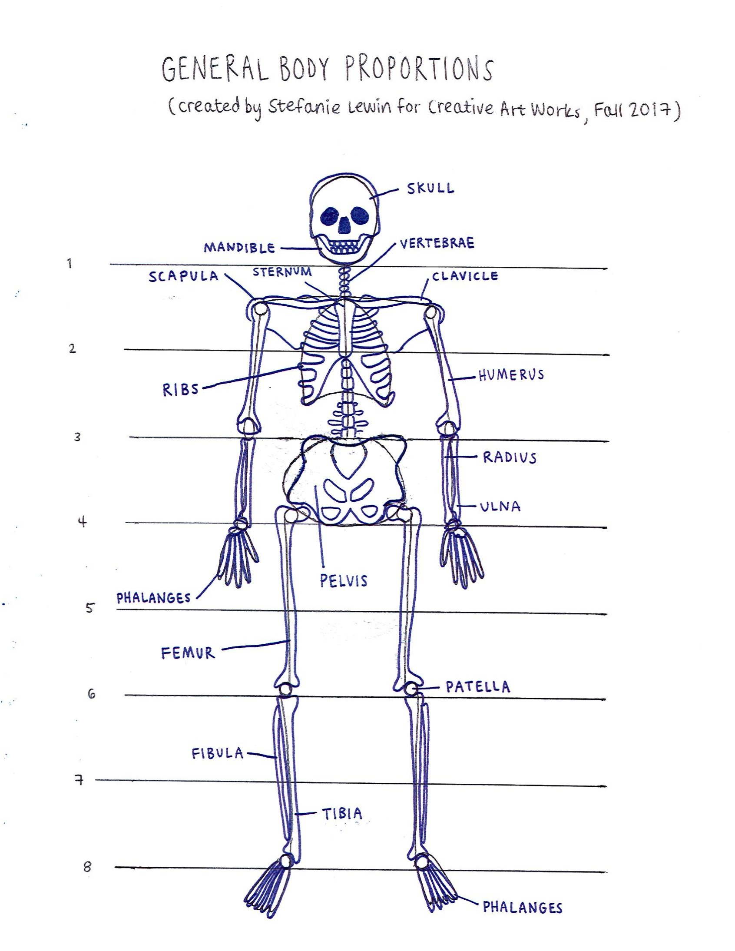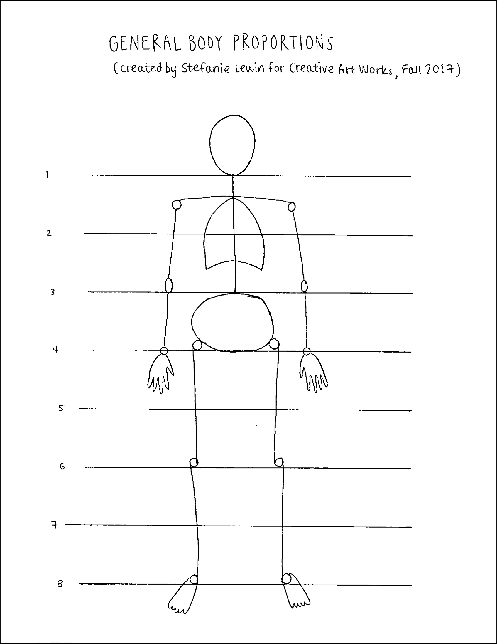

CLASS 2

Title: Skeleton Drawings (continued)

Learner Objectives:
SWBAT
• create an expressive drawing that reflects the action of a figure.
• learn how to draw rapidly and continuously in a ceaseless line that records the gesture.
• observe examples of gross anatomy and become familiar with aspects and proportions of the skeleton
• develop an understanding for drawing the skeleton to establish a framework upon which to hang the muscles.
• identify and name various parts of the skeleton: skull, scapula, etc.

Student Outcome:
• Warm up activity: students make gesture drawings of comic characters as reference using vine charcoal on newsprint. Images projected on wall to recreate working from
posed model.
• Students continue their drawings of the human skeleton using vine charcoal on drawing paper.

Motivation/Inspiration
Inspiration: Daredevil, Rogue, Storm and, The Hulk (and TA samples)
Generate ideas for their character. Sketch ideas.

Vocabulary:
Anatomy, gross anatomy, gesture, names of specific bones: skull, vertebrae, see handout.

Materials:
Skeleton
Wood Mannequins
Project (skeleton image)
Vine charcoal soft
Oil pastels
Conte crayon
Newsprint pad-smooth 18 x 24”
Drawing paper 12x18”
Pencil
erasers

Resources:
Kimon Nicolaides, The Natural Way to Draw.

In Session Prompts:
Gesture:
• “Draw not what the thing looks like, not even what it is, but what it is doing.” -Kimon Nicolaides.
• “In the first 5-10 seconds of the pose, you should put something down that shows every part of the body in the pose.”
• “Remember to draw from the center of the figure out toward the edges.”
Skeleton Drawing:
• “Vine charcoal is easy to erase and draw over. You can also create different types of lines - think, thin …”
• “Remember that the human figure is 7+ heads high.”

Assessment:
- Did the student participate during group conversations, either by raising their hands and sharing their thoughts or by paying attention and engaging with the class (e.g. looking at the speaker, remaining quiet while others were speaking)?
- Did the student follow along with the human proportions worksheet to create their own diagram?
- Did the student clean up their workspace to a satisfactory degree (materials in plastic bag, papers in portfolio, any trash in trash can)?

Reflection:
- How was working with charcoal this time?
- How is it different from drawing with a pencil or pen?
- What is something that surprised you about the proportions of the human body?
- Do you feel ready to work on a more detailed drawing next week, or is there anything you think you might get hung up on?

Tasks for Assistant/Citizen’s Teacher
• Handing out materials
• Keeping student on task, especially during transitions.

CLASS 2

Lesson Element | Time | Description of Process
Introduction | 5  2-5 min | Review from last week, read community agreement.  -TA present cartoon/comic images that highlight anatomy  -Gesture drawing from projected images of comic characters, vine charcoal on newsprint.  Timed drawings: 10 sec, 5 sec, etc.  Look at drawings  Materials  Vine charcoal (soft)  -Newsprint pad -smooth, 8.5x12  -Projector  -Images for gesture drawing on flash drive
Demonstration |  | Active demos throughout class:  -Gesture drawing from projected images.  -Skeleton drawing. Building form using simple shapes, similar to those on wood mannequin.
Work Period | 70  2-3 | Skeleton Drawing – review  -measure on the skeleton, using the length of the head as the unit of measurement  -general shapes for areas of figure: oval, rectangular, etc.  Mid class reflection – check in  Continue Drawing  Materials  -Skeleton (from science lab)  -Vine charcoal (soft)  -Drawing paper 12”x 18”  -Skeleton handout
Clean Up | 5
Wrap Up | 5-10 | Critique in-progress anatomy drawings.  TA introduce critique etiquette. TA can use poster with sentence starters/prompts.  For next week: Begin thinking about your character

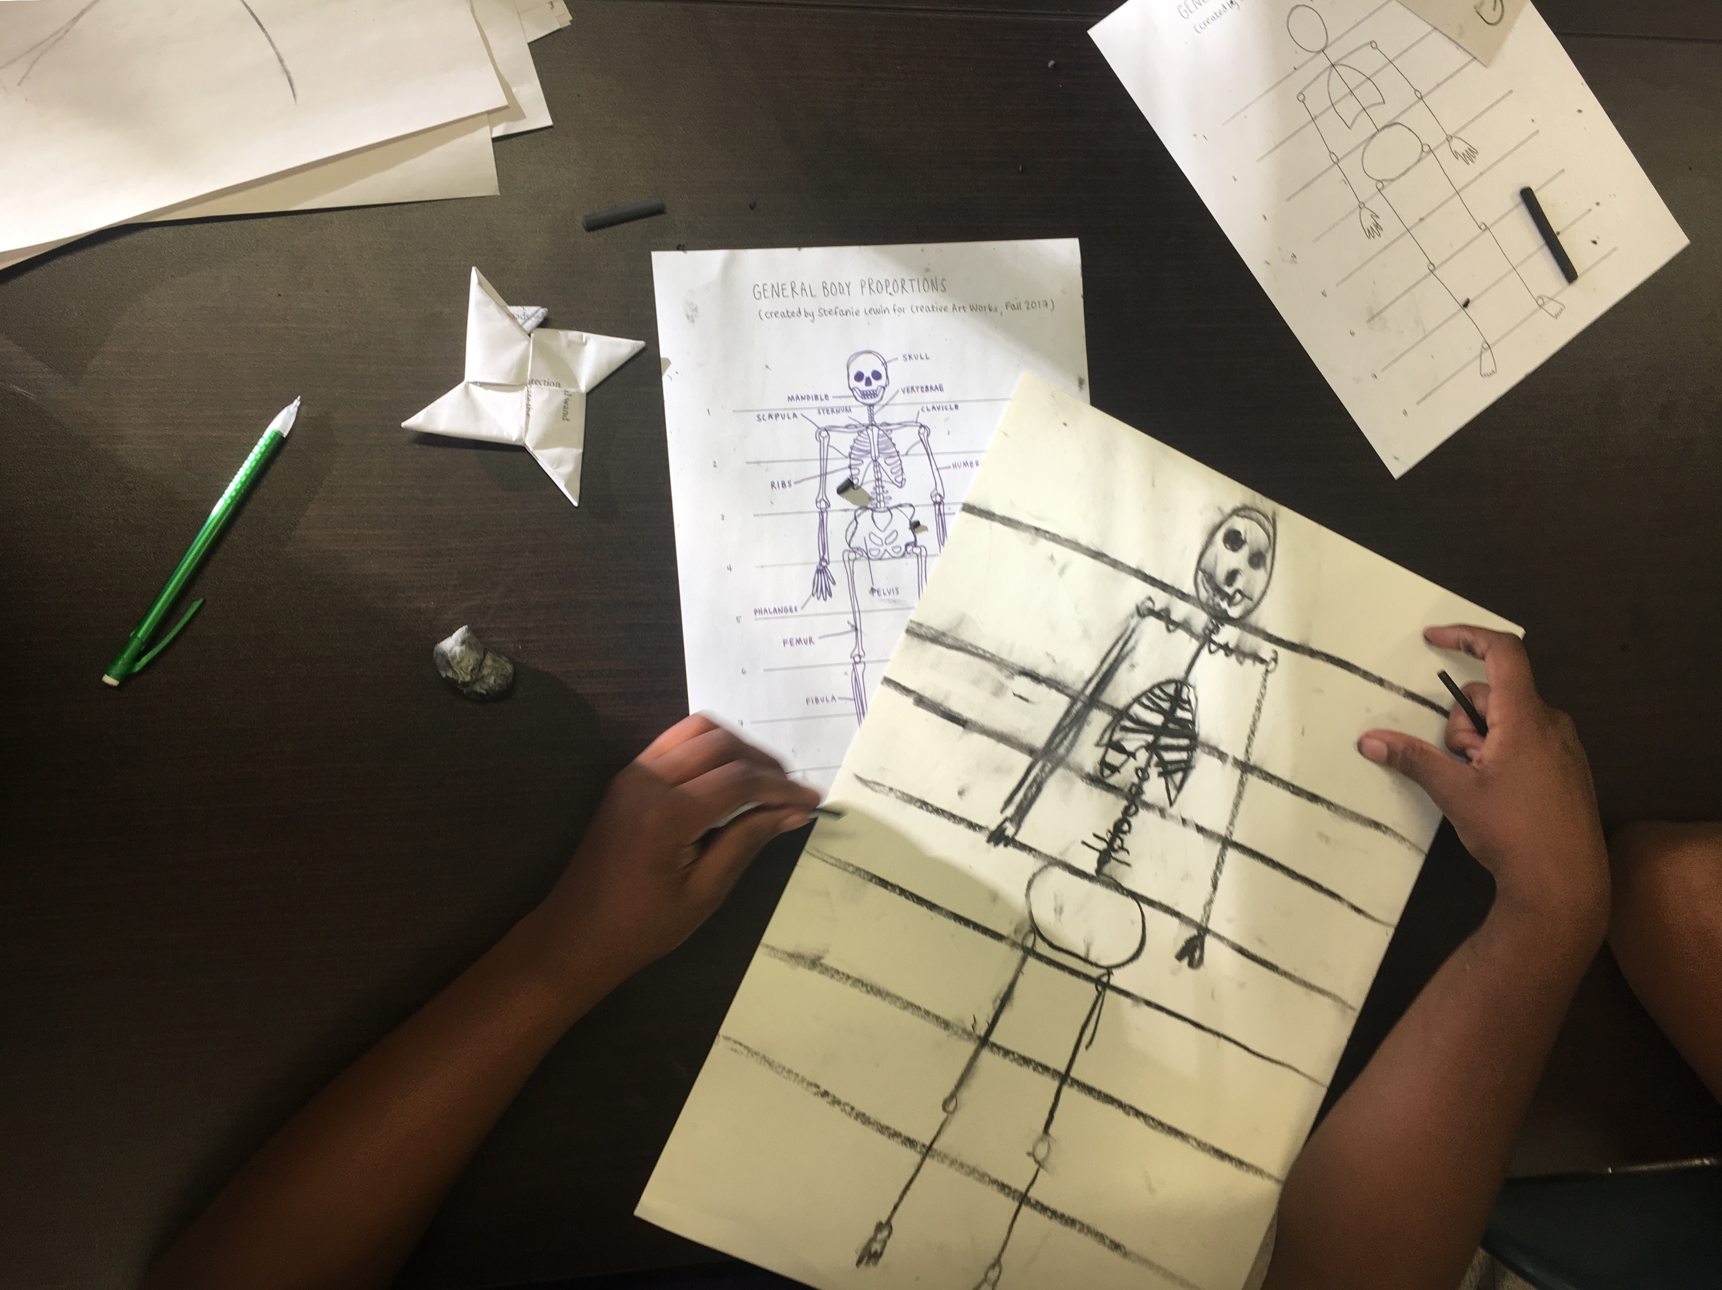

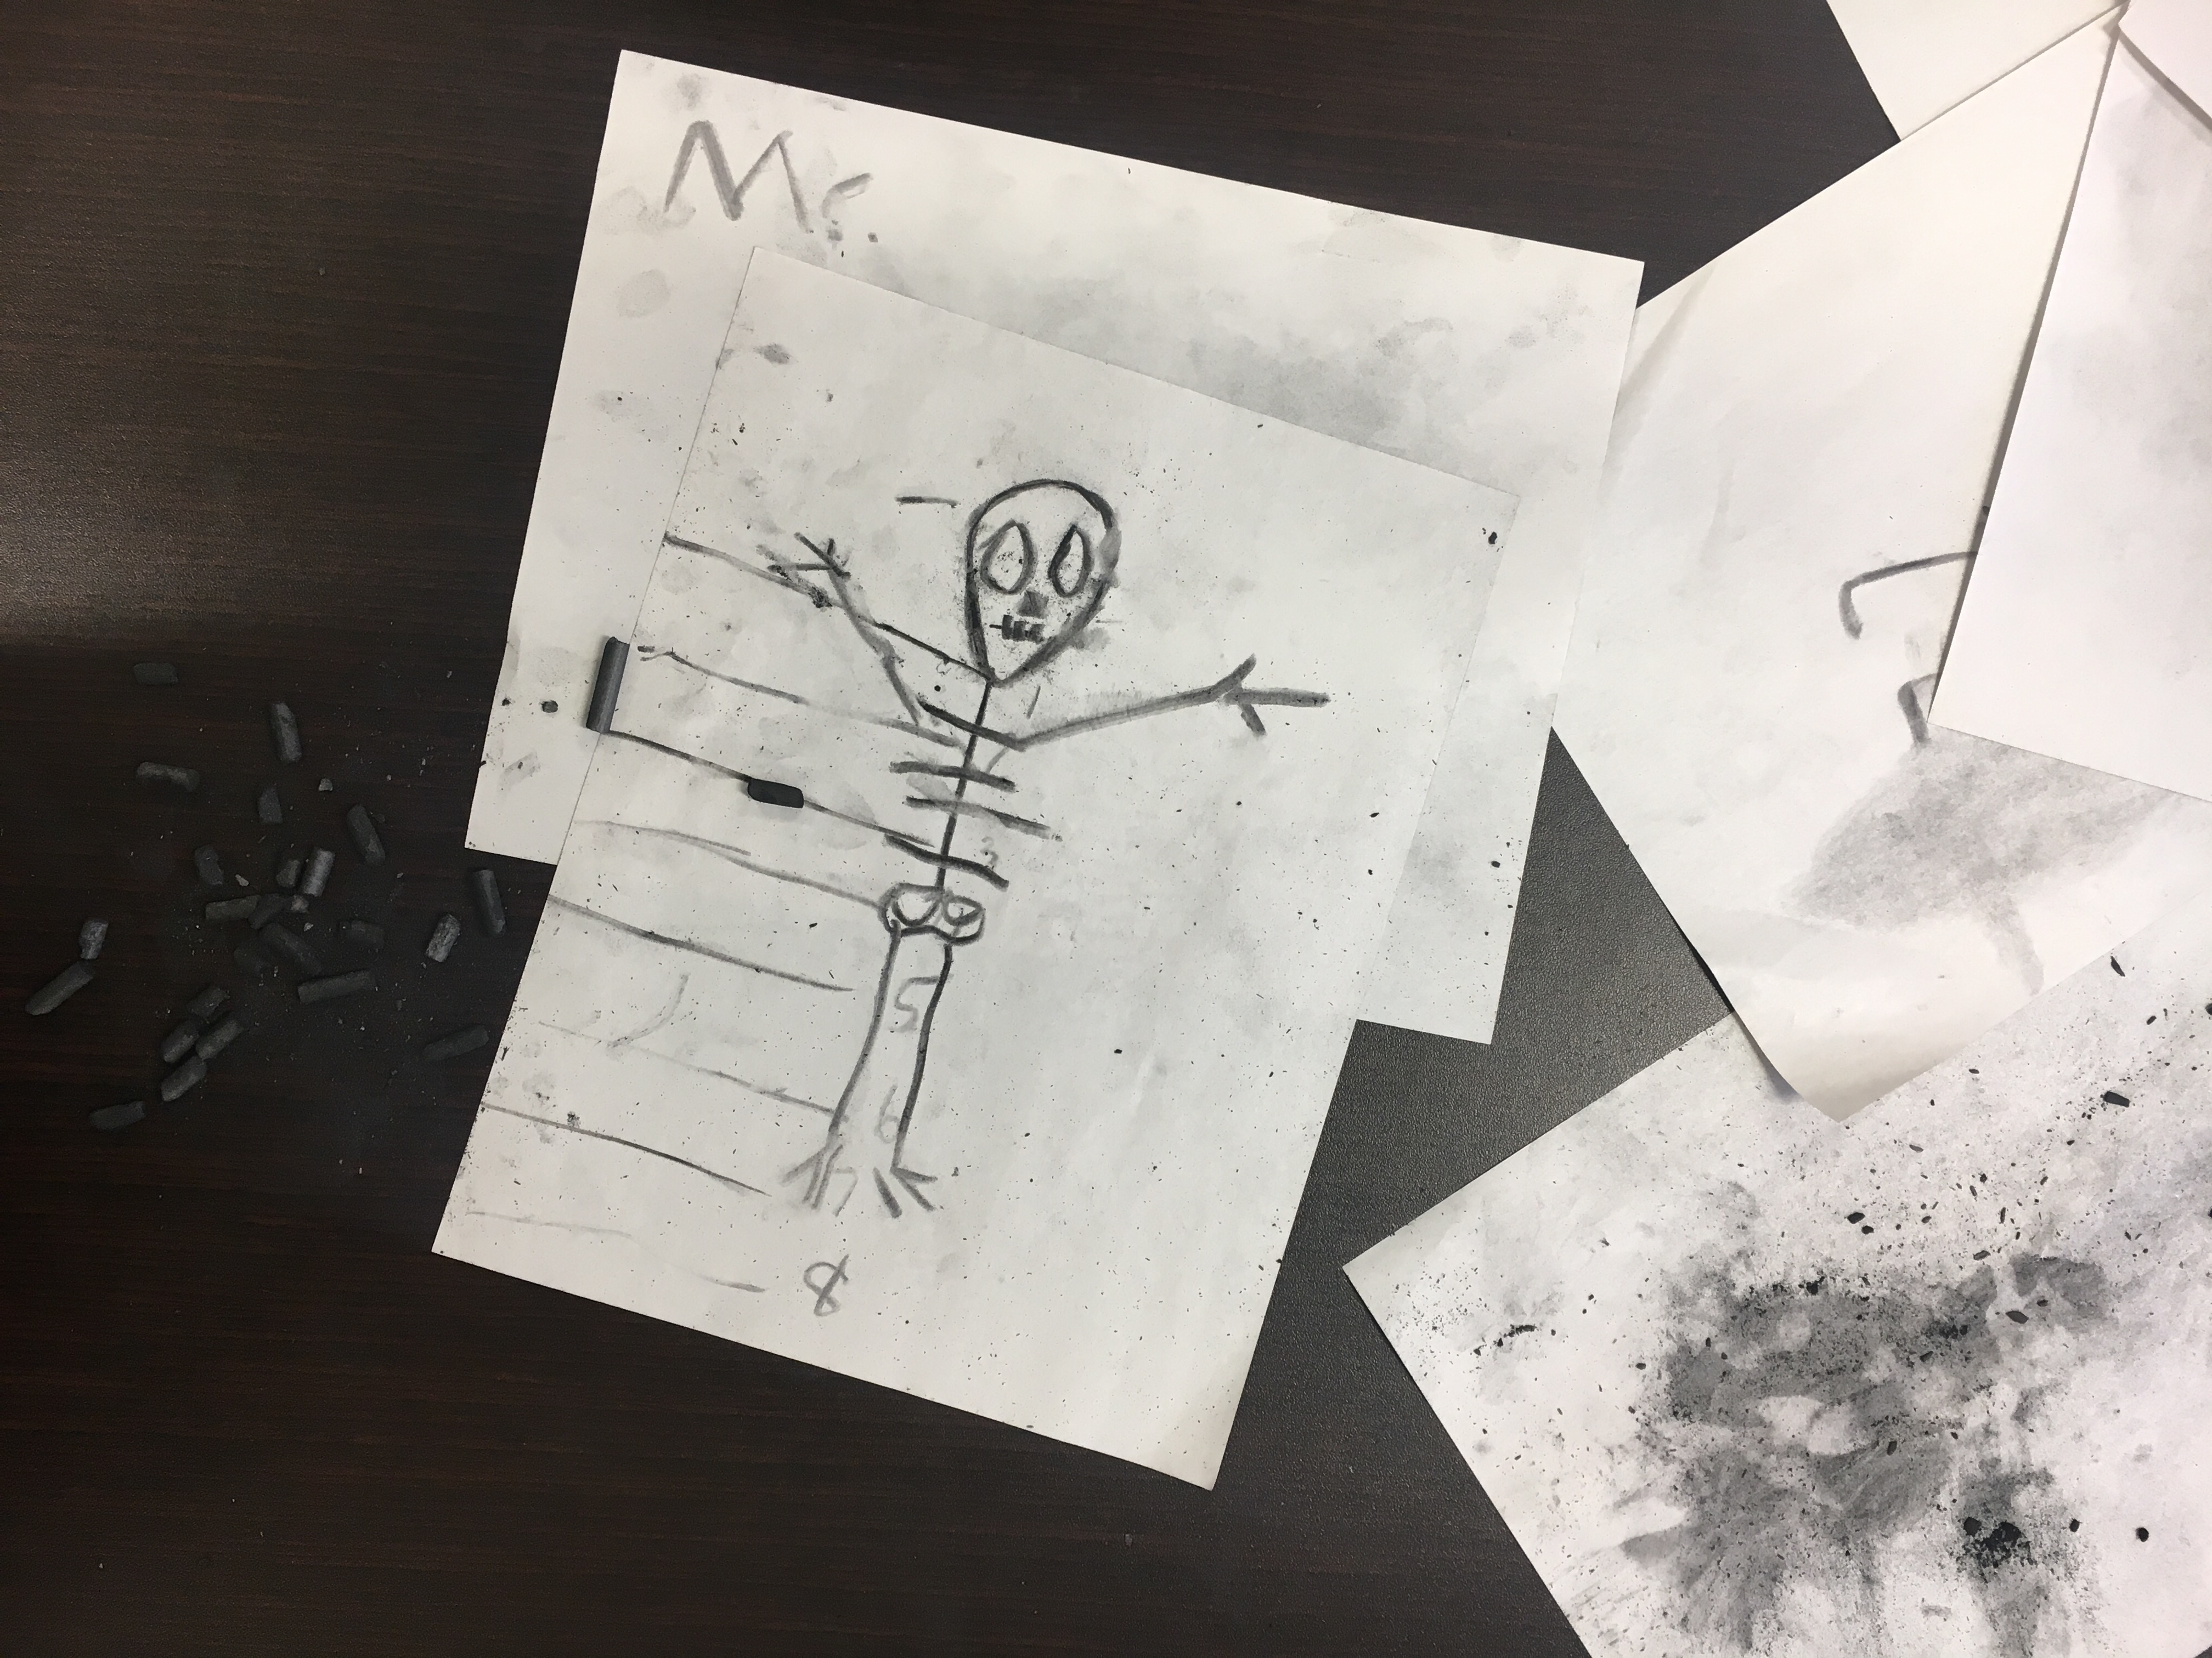
CLASS 3
Title: Skeleton drawing and Muscular layer drawing

Learner Objectives:
SWBAT
Students will:
-observe examples of gross anatomy and become familiar with muscle groups: biceps, triceps, quadriceps, etc.
- create gesture drawings and life drawings using comic characters as reference.
- create drawings of the skeletal and muscular systems using materials of TA’s choice.

Student Outcome:
Anatomical overlay drawings - students will finish skeleton using vine charcoal on paper and begin muscular layer drawings using cray-pas on tracing paper.

Motivation/Inspiration
- Gesture drawing warm-up
- TA sample

Vocabulary
Biceps, triceps, quadriceps (quads), latissimus dorsi (lats), abdominal external oblique (obliques), hamstrings.

Materials
Skeleton
Wood mannequins
Vine charcoal
Newsprint smooth
Drawing paper 12”x18”
Tracing Paper 12”x18”
Masking tape
Pencils
Erasers
Cray pas
Paper Clips
Index cards/post-it notes (for exit ticket)

Resources
- https://www.geek.com/geek-cetera/animation-style-guides-for-your-favorite-tv-shows-are-extremely-cool-1643995/
- Musculature handouts

In Session Prompts
- Most skeletons are pretty similar, but once we add muscles we all start to look unique!
- Keep thinking about your character… would they have very defined muscles? Do they need to run/jump/punch/etc?
- Try using different colors to define each separate muscle group
- One-on-one conversations with students during studio time

Assessment
- Student engagement (staying on task, taking time and care to draw all bones and muscles pictured in the handouts)
- Level of detail in drawings (does it appear that the student actually observed the handout and made an effort to draw accurate anatomy?)

Reflection
- What the most challenging part of the drawing? Why? Did anyone else experience that?
- Was there an easier part of the drawing? Why?
- Was the handout helpful?

Tasks for Assistant
- Keeping student on task, especially during transitions.
- Writing up key words
- Explaining parts of the art making process
- Handing out materials
- Engaging in thoughtful discussion with students during art-making
- Helping to install and display work for Reflection

CLASS 3

Lesson Element | Time | Description of Process
Introduction | 5 min | -Review from last week, overview for today’s class.  -While working today think about your character.
Demonstration | 5 min
Work Period | 5 min  40 min | Life Drawing  -Gesture drawing warm-up (3)  Anatomy drawings  -Students complete skeleton drawings.  -Begin muscular layer drawings. Follow handout.
Clean Up | 5 min
Wrap Up | 15 min | Gallery walk  Exit ticket: write or draw one thing about your character

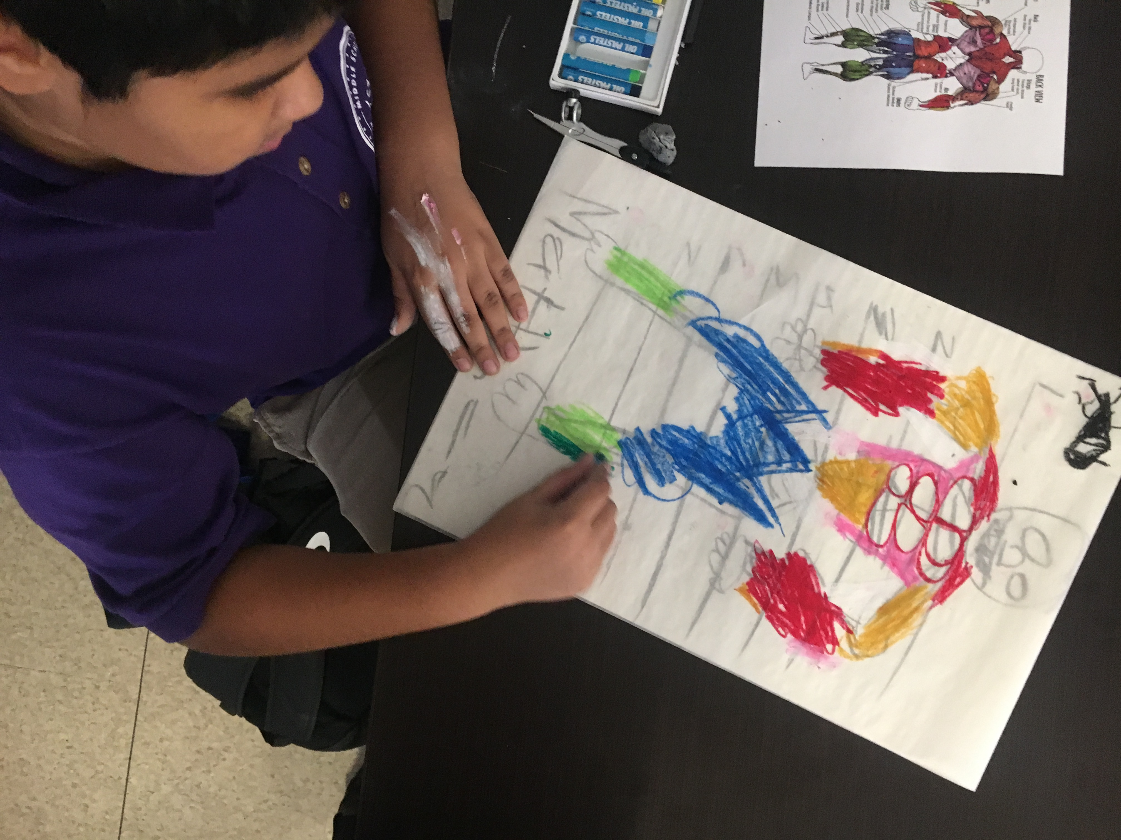

CLASS 4
Title: Skeleton drawing and Muscular layer drawing – complete

Learner Objectives:
SWBAT
-observe examples of gross anatomy and become familiar with muscle groups: biceps, triceps, quadriceps, etc.
- create gesture drawings and life drawings using comic characters as reference.
-create drawings of the skeletal and muscular systems using materials of TA’s choice.

Student Outcome:
Anatomical overlay drawings - students will finish skeleton using vine charcoal on paper and begin muscular layer drawings using cray-pas on tracing paper.

Motivation/Inspiration
- Gesture drawing warm-up
- TA sample

Vocabulary:
Biceps, triceps, quadriceps (quads), latissimus dorsi (lats), abdominal external oblique (obliques), hamstrings, symmetry.

Materials:
Wood mannequins
Vine charcoal
Newsprint smooth
Drawing paper 12”x18”
Tracing Paper 12”x18”
Masking tape
Pencils
Erasers
Cray pas
Paper Clips
Index cards/post-it notes (for exit ticket)

Resources:
- https://www.geek.com/geek-cetera/animation-style-guides-for-your-favorite-tv-shows-are-extremely-cool-1643995/
- Musculature handouts

In Session Prompts:
- Keep thinking about your character… would they have very defined muscles? Do they need to run/jump/punch/etc?
- Since the figure is symmetrical, think of the muscles in pairs. When you add one muscle group, add its pair on the other side of the line of symmetry.
- One-on-one conversations with students during studio time

Assessment:
- Student engagement (staying on task, taking time and care to draw all bones and muscles pictured in the handouts)
- Level of detail in drawings (does it appear that the student actually observed the handout and made an effort to draw accurate anatomy?) Look for placement of muscle groups and relative sizes.
- Was the student able to follow the prompts and muscles in pairs, on each side of the line of symmetry?

Reflection:
- “What did you think about working with oil pastel on top of tracing paper?”
- “How is it different from drawing with pencil on paper?”
- “What is something that surprised you about the proportions of the muscular system.”
- “What did you learn on today’s drawing that you can apply to next classes drawing?”
- “Would anyone like to share any techniques for how they are working with oil pastel? Mixing color, scratching out the oil pastel, etc”

Tasks for Assistant:
- Keeping students on task, especially during transitions.
- Writing up key words
- Explaining parts of the art making process
- Handing out materials
- Engaging in thoughtful discussion with students during art-making
- Helping to install and display work for Reflection

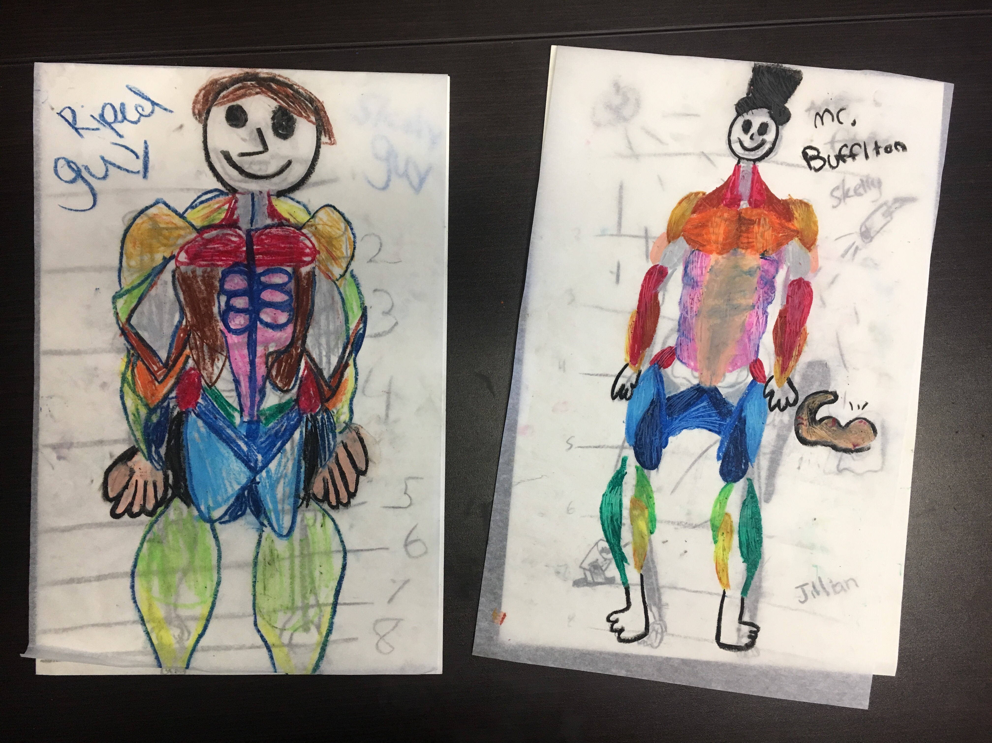

CLASS 4

Lesson Element | Time | Description of Process
Introduction | 3 min  10 min | -Review from last week  -Begin talking about how clothing/accessories/pose can indicate character and backstory (use comic examples)
Demonstration | 5 min | Demo labeled character diagram (using Liz Prince drawing from “Tomboy” as inspiration) Or other samples based upon student interest.
Work Period | 5 min  40 min | Life Drawing  -Gesture drawing warm-up  Character Diagrams – label physical features that connect with character attributes (e.g. Ms. Marvel’s elongated arm, special armbands or aspects of an outfit).
Clean Up | 5 min
Wrap Up | 15 min | Introduce critique etiquette, TA can use poster with sentence starters/prompts  See Reflection questions.

CLASSES 5 and 6
Title: Character diagram

Learner Objectives:
SWBAT
• understand that a character profile is a convention within comics
• learn how to create a character profile by drawing their character and writing about their attributes, or labeling physical features.
• create drawings of their character from multiple vantage points (front, side, back) to be used as reference for future project.

Student Outcome:
Students will create a character diagram of their character providing insight into their character’s attributes and attire. Some students may opt to create a character profile that includes 2-3 drawing front, side, and back to be used as reference.

Motivation/Inspiration
Gesture drawing warm-up

Vocabulary: character diagram, character profile, symmetry

Materials:
Wood mannequins, Vine charcoal, Newsprint smooth, Drawing paper 12”x18”
Tracing Paper 12”x18”, Masking tape, Pencils, Colored Pencils, Erasers
Index cards/post-it notes (for exit ticket).

Resources:
- https://www.geek.com/geek-cetera/animation-style-guides-for-your-favorite-tv-shows-are-extremely-cool-1643995/
- Musculature handouts

In Session Prompts:
- “Remember to add notes as you develop your character.”
- “Select a character diagram OR profile as a guide for your drawing”.
- “Use your knowledge of anatomy to build your figure”.

Assessment:
- “For students making a character profile, were they able to draw their character from front, back, and side?”
- “For students making a character diagram, did they add notes that explain the character’s attributes?”

Reflection:
- Do you feel ready to complete these by next week in full color, or is there anything that might take you longer?
- As an artist community, how we support each other? Techniques, ideas, what else?”

Tasks for Assistant:
- Keeping students on task, especially during transitions.
- Writing up key words
- Explaining parts of the art making process
- Handing out materials
- Engaging in thoughtful discussion with students during art-making
- Helping to install and display work for Reflection

CLASS 5

Lesson Element | Time | Description of Process
Introduction | 5 min  10 min | -Review from last week.  Overview for today-complete character profile  -Begin talking about how clothing/accessories/pose can indicate character and backstory (use comic examples)
Demonstration | 5 min | Demo labeled character diagram (using Liz Prince drawing from “Tomboy” as inspiration).  Ms. Marvel, Wolverine, Black Panther samples for character profile.
Work Period | 5 min  50 min | Life Drawing  -Gesture drawing warm-up  -Character Diagrams - label physical features that connect with character attributes (e.g. Ms. Marvel’s elongated arm, special armbands or aspects of an outfit). Show examples as needed.
Clean Up | 5 min
Wrap Up | 10 min | OPTIONS  1. Group reflection  2. Small groups - Student share 1-2 minutes each.  3. Post-it notes - Students write out one thing that you like about it and one thing that you have a question about.

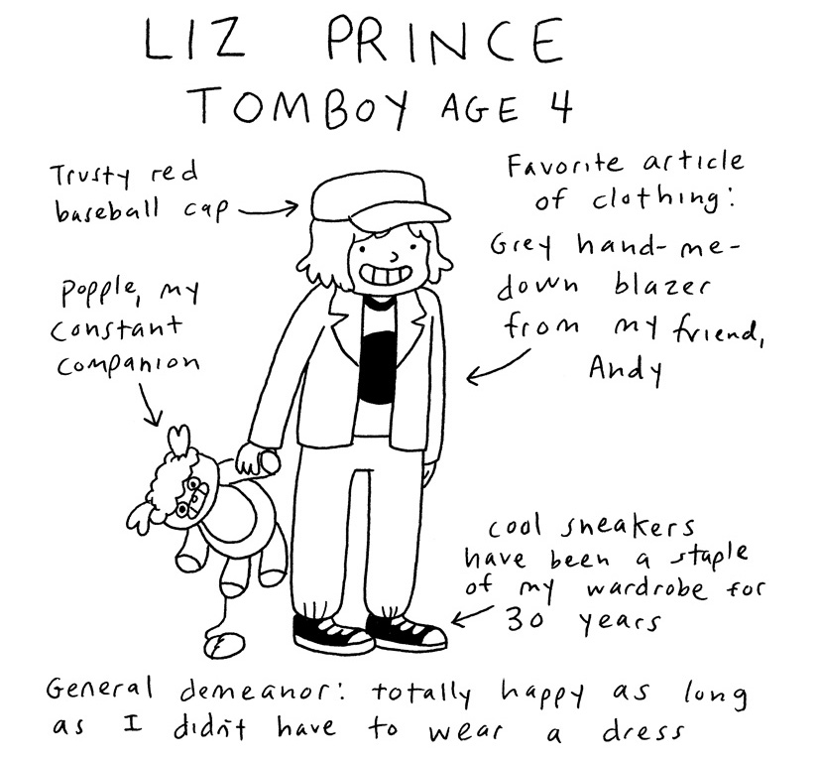

Character Diagram

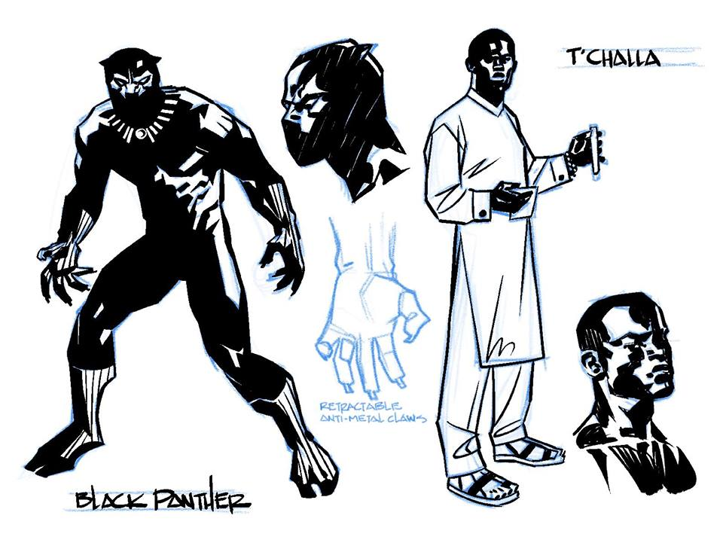

Character profile

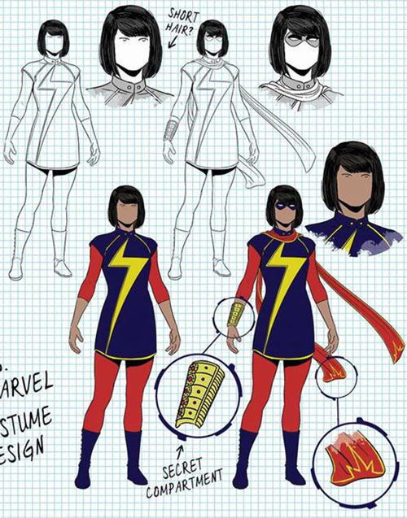

Character profile – Ms Marvel

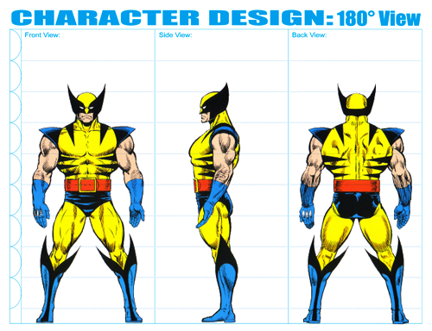

Class 6
Complete character diagram or profile

Lesson Element | Time | Description of Process
Introduction | 5 min  10 min | -Review from last week.  Overview for today-complete character profile  Group check-in and reflection  - Who has a good idea of their character? How is everyone feeling as we move into the second half of the program and get closer to the culminating event?  - Did anyone get interesting feedback from last week’s post-it note activity? Has anyone made any decisions about their characters as a result?
Demonstration | 5 min | Demo labeled character diagram (using Liz Prince drawing from “Tomboy” as inspiration).  Ms. Marvel, Wolverine, Black Panther samples for character profile.
Work Period | 5 min  50 min | Life Drawing  -Gesture drawing warm-up  -Character Diagrams - label physical features that connect with character attributes (e.g. Ms. Marvel’s elongated arm, special armbands or aspects of an outfit). Show examples as needed.
Clean Up | 5 min
Wrap Up | 10 min | Group critique  -Exit ticket: fill out index card with character name and one notable thing about them (their job, their superpower, their best quality, their hometown, their nemesis, their favorite food… anything!) Must be a new idea.

Classes 7 and 8
Title: Figure Sculpting – Armature wire

Learner Objectives:
SWBAT
• learn basic materials and techniques for using Armature wire such as bending, curling and attaching.
• develop an understanding for translating 2D image to a 3D form.
• develop an understanding for creating 3D characters

Student Outcome:
Students will create a skeletal framework for the maquette of their character using Armature wire.

Motivation/Inspiration
Warm up activity-gestrure drawing from projected images.

Vocabulary
Maquette, mannequines, two dimensional, three dimensional, framework.

Materials:
Vine charcoal (soft), Newsprint pad-smooth 18 x 24”, Armature wire, 14 gauge
Skeleton drawings

Resources:
See Jessie’s

In Session Prompts:
- “Try using 3 different pieces of wire to create the framework. One for the torso, one for the arms, one for the legs.”

Assessment:
- Did the student experiment make an effort to experiment with the armature wire. Were they able to bend, curl the wire? Were they able to conect two pieces of wire?

Reflection:
- What did you think about working with armature wire?
- What is something that surprised you about this material?

Tasks for Assistant:
- Keeping students on task, especially during transitions.
- Writing up key words
- Explaining parts of the art making process
- Handing out materials
- Engaging in thoughtful discussion with students during art-making
- Helping to install and display work for Reflection

Class 7 Figure sculpting

Lesson Element | Time | Description of Process
Introduction | 5 min | Review from previous class
Demonstration | 5 min | Active demos: Armature wire
Work Period | 5 min  10  10  35 | Warm up: Gesture drawing from projected images  Open Exploration  Armature wire -experiment with materials  Guided Explorations as a group  Prompts: make a sharp corner, a curved form, attach pieces of wire.  Making the framework  Use 3 pieces of wire for torso, arms, and legs.
Clean Up | 10 min
Wrap Up | 10 min | Reflection

Class 8 Figure sculpting

Lesson Element | Time | Description of Process
Introduction | 5 min | Review from previous class
Demonstration | 5 min | Active demos: Armature wire
Work Period | 5 min  35 | Warm up: Gesture drawing from projected images  Complete framework  Use 3 pieces of wire for torso, arms, and legs.
Clean Up | 10 min
Wrap Up | 10 min | Reflection

Classes 9 and 10
Figure Sculpting – musculature

Learner Objectives:
SWBAT
• learn basic materials and techniques for using Plasticine clay such as shaping, pinching, and smoothing.
• develop an understanding for translating 2D image to a 3D form, by using their skeleton and mucular layer drawings as reference.
• develop an understanding for creating 3D characters

Student Outcome:
Students will add the muscles to the skeletal framework of the maquette my molding them out of plasticine clay.

Motivation/Inspiration
Artist samples, TA sample.

Vocabulary
Shaping, pinching, and smoothing.
Muscle groups from handout.

Materials:
-Vine charcoal (soft)
-Newsprint pad-smooth 18 x 24”
-Plasticine clay
-Skeleton drawings
-Masking tape

Resources:
See Jessie’s

In Session Prompts:
“Try using 3 different pieces of wire to create the framework. One for the toes, one for the arms, one for the legs.”

Assessment:
Was student able to

Reflection:
What did you like about this?
Was anything challenging? How did you problem solve?

Tasks for Assistant:
Same
Class 9
Figure sculpting – Musculature

Lesson Element | Time | Description of Process
Introduction | 5 min | Review from previous class
Demonstration | 5 min | Active demos: Crayola white clay
Work Period | 5 min  10  10  35 | Warm up: Gesture drawing from projected images  Open Exploration  White air dry clay-experiment with materials  Guided Explorations as a group  Prompts: make 3 different types of forms  Adding muscles to the framework  Students use their skeleton and muscular layer drawing as reference. Mold muscle groups and add to framework.
Clean Up | 10 min
Wrap Up | 10 min | Reflection

Class 10
Figure sculpting – Musculature

Lesson Element | Time | Description of Process
Introduction | 5 min | Review from previous class
Demonstration | 5 min | Active demos: White air dry clay
Work Period | 5 min  50 | Warm up: Gesture drawings from projected images  Complete adding muscles to framework
Clean Up | 10 min
Wrap Up | 10 min | Reflection - gallery walk

Classes 11, 12, 13
Title: Action books

Learner Objectives:
SWBAT
• learn how to draw the figure/their character from muliple vantage points ising their posable maquette as reference.
• develop an understanding for how some artists create consistently drawn 3D characters.

Student Outcome:
Create an accordian book that visuallu narrates their character’s origin story.

Motivation/Inspiration
Artist samples, TA sample.
What is an origin story? What happened to your character to make them into the person they are today.

Vocabulary
Sequence, accordian, origin.

Materials:
Copy paper or 9”x12” drawing paper, Pencil, Erasers, Sharpie markers (fine point, ultra fine point), Colored pencils.

Resources:
See Jessie’s

In Session Prompts:
“Pose the maquette in at least 3 different poses for the book.”
“You can experiment by making gesture drawings of your maquette.” Posed and timed drawings as group.

Assessment:
Was student able to to capture the correct proportions in their drawings?
TA, have you noticed that the students drawing skills have improved since doing gesture drawings as a warm up activity?

Reflection:
What did you like about this?
Was anything challenging? How did you problem solve?

Tasks for Assistant:
Same

Class 11 Action book - sketches

Lesson Element | Time | Description of Process
Introduction | 5 min | Review from previous class  What is an origin story? Student share out.
Demonstration | 5 min | Active demos:  Show students hoe to make a one-page zone (6 pages, folded and cut from one sheet of printer paper).
Work Period | 10 min  40 | Planning time (sketch character, sketch sequence of actions).  Students will illustrate comic book zones (action books) telling the story of their character’s origin story.
Clean Up | 10 min
Wrap Up | 10 min | Reflection

Class 12
Action book – enlarge sketches. Add simple settings. Landscape/cityscapes.

Lesson Element | Time | Description of Process
Introduction | 5 min | Review from previous class  What is an origin story? Student share out.
Demonstration | 5 min | Active demos:  Show students hoe to make a one-page zone (6 pages, folded and cut from one sheet of printer paper).
Work Period | 10 min  40 | Planning time (sketch character, sketch sequence of actions).  Students will illustrate comic book zones (action books) telling the story of their character’s origin story.
Clean Up | 10 min
Wrap Up | 10 min | Reflection

Class 13
Action book- adds color.

Lesson Element | Time | Description of Process
Introduction | 5 min | Review from previous class  What is an origin story? Student share out.
Demonstration | 5 min | Active demos:  Show students hoe to make a one-page zone (6 pages, folded and cut from one sheet of printer paper).
Work Period | 10 min  40 | Planning time (sketch character, sketch sequence of actions).  Students will illustrate comic book zones (action books) telling the story of their character’s origin story.
Clean Up | 10 min
Wrap Up | 10 min | Reflection

Class 14 - Final Projects - Begin
Comic zone (cartooning focus) or large comic book cover (anatomy focus)

Learner Objectives:
SWBAT
• Understand the visual language of comics, such as conventions in superhero comic covers.
• Understand that comic artists begin with a sketch in order to plan their work.
• Create sketches combined with writing to plan their projects.

Student Outcome:
Students will create the first step for the project by completing either multiple sketches for a comic book cover or a storyboard handout for a comic zone.

Motivation/Inspiration
Comic samples
TA samples

Vocabulary: zone, narrative, origin, myth, sketch, storyboard, reference

Materials:
Comic Zane
Drawing paper 9x12 OR Copy paper, pencil, eraser, Sharpie, Chanson Multi Media XL paper 18”x24”

Comic Cover
Pencil, eraser, Sharpie, Chanson Multi Media paper 9x12”, Color pencils

Resources:
- Storyboard handout

In Session Prompts:
• “Just get your ideas down, these are not supposed to be finished drawings.”
• if you are making a comic cover, think about the pose/gesture and the title of the comic book introducing this new character.
• “Use you character diagram as reference.”

Assessment:
• Were students able to sketch out their ideas without getting too caught up in making detailed drawings? Getting the gist of the idea.
• Did students use their character diagram as reference for drawing their character?
• Did students add notes to their sketches to explain other ideas?

Reflection:

Tasks for Assistant:
- Keeping students on-task
- Anticipating transitions

Comic cover

Lesson Element | Time | Description of Process
Introduction | 5 min | Introduce final project.  Student options:  Comic zine  -Focus on storytelling and sequence of images.  -Learning/knowledge of anatomy is reflected in drawing, but is second to the storytelling.  -Possible content: your character’s origin myth.  -TA will come up with page requirement.  Comic cover  -focus on pose/gesture.  -cover of the book.  Look at artist samples
Demonstration | 5-7 min | TA demos  Zine -focus on keeping figures simple.  KIS -just lay out the drawings.  Cover -show sketch in progress:  This can include: pose/gesture referencing character diagram, title of comic, introducing your character.
Work Period | 50 min | Begin working on final projects:  -Comic zine group focus on getting story mapped out in sequence and getting pencil drawings done.  -Comic cover begins sketching their large drawings, can start point-to-point blow up when they’re ready, focus on getting pencil done today
Clean Up | 5 min
Wrap Up | 10 min | Group critique in progress OR small group critiques

Class 15 - Final Projects – Refine and Transfer
Comic zine (cartooning focus) or large comic book cover (anatomy focus)

Learner Objectives:
SWBAT
• understand the visual language of comics, such as conventions in superhero comic covers.
• understand that comic artists begin with a sketch sketch in order to plan their work.
• create sketches combined with writing to plan their projects.

Student Outcome:
Students will create the first step for the project by completing either multiple sketches for a comic book cover or a storyboard handout for a comic zine.

Motivation/Inspiration
Comic samples
TA samples

Vocabulary: zine, narrative, origin, myth, sketch, storyboard, reference

Materials:
Comic Zine
Drawing paper 9x 12 OR Copy paper, pencil, eraser, Sharpie, Canson Multi Media XL paper 18”x24”

Comic Cover
Pencil, eraser, Sharpie, Canson Multi Media paper 9x12”, Color pencils
Rulers

Resources:
- Storyboard handout
- Comic cover examples for type

In Session Prompts:
• “Just get your ideas down, these are not supposed to be finished drawings.”
• If you are making a comic cover, think about the pose/gesture and the title of the comic book introduing this new character.
• “Use you character diagram as reference.”

Assessment:
• Were students able to sketch out their ideas without getting too caught up in making detailed drawings? Getting the gist of the idea.
• Did students use their character diagram as reference for drawing their character?
• Did students add notes to their sketches to explain other ideas?

Reflection:
-what are you liking about your work?
-is there anything else that might help to communite these artist’s ideas?

Tasks for Assistant:
- Keeping students on-task
- Anticipating transitions

Comic cover

Lesson Element | Time | Description of Process
Introduction | 3 min | Review from previous week  Refine drawings and transfer to final surface.  Look at artist samples, post on walls etc, so students can see.
Demonstration | 5-7 min | TA demos:  Transferring from storyboard worksheet to comic zine final surface.  Zines: fold paper as practice  Fold paper for final, begin to transfer. Draw lightly, refine as you go.  Cover: refine small drawing.  Point to point blow up or enlarge freehand
Work Period | 30 min  3  30 min | Refine-Comic cover begins sketching their large drawings, can start point-to-point blow up when they’re ready.  Mid class reflection*: studetns share examples or nominate peers.  Transfer
Clean Up | 5 min
Wrap Up | 10 min | Can move Reflection* up so students can use feedback to go back into their work.

Class 16 - Final Projects – adding color
Comic zine (cartooning focus) or large comic book cover (anatomy focus)

Learner Objectives:
SWBAT
• understand basic color theory through learning related vocabulary terms and completing exercises.
• understand how artists utilize color theory to inform their color choices when creating a work of art.
• create a color wheel using only primary colors.
• practice color mixing using tempera paint

Student Outcome:
Students will add color to their works -comic zine using sharpie and watercolor.
Comic cover -Sharpie and tempera

Motivation/Inspiration
Comic samples
TA samples

Vocabulary: color theory, primary, secondary, tertiary(?), warm colors, cool colors, complementary colors, analogous, palette, advancing and receding colors (identify in comics).

Materials:
Comic Zine
Drawing paper 9x12” OR Copy paper 8.5x11, pencil, eraser, Sharpie, Canson Multi Media XL paper

Comic Cover
Pencil, eraser, Sharpie, Canson Multi Media paper 9x12”, Color pencils (for color sketch) Rulers 18”, tempera paint, tempera brushes, muffin tins, paper palettes,
paper towels.

Resources:
- Storyboard handout
- Comic cover examples for type

In Session Prompts:
When deciding your palette, you can practice with color relationships in your sketchbook. Try analogous ‘color families.’

Assessment:
• Did students use their color wheel and color experiments as reference for their palette?
• Did students add notes to their color sketches to remember color recipes.

Reflection:
-What do you like about your work in progress?
-Is there anything else that might help to communicate these artist’s ideas?
-Group discussion re: exhibition

Tasks for Assistant:
- Keep students on-task
- Anticipate transitions

Class 16 - Final Project - Adding color

Lesson Element | Time | Description of Process
Introduction | 3 min | Review from previous week  Overview for today: adding color  Study color theory using color wheel.  Look at artist samples, post in classroom.
Demonstration | 5-7 min | TA Active demo:  Create color wheel using tempera.  Zines: Outline with sharpie, watercolor on top.  Cover: Sharpie over pencil to retain drawing. Tempera on top.
Work Period | 60 min | Outline with sharpie, watercolor or tempera on top.
Clean Up | 5 min
Wrap Up | 10-15 min | Artist statement notes in sketchbook.  Gallery walk

Class 17 – Final Projects continue

Lesson Element | Time | Description of Process
Introduction | 5 min | Review from previous week  Look at works in progress.
Demonstration | 5-7 min | TA demos as needed
Work Period | 60 min | Work on final projects
Clean Up | 10 min
Wrap Up | 10-15 min | Artist statement notes in sketchbook.  Group discussion about culminating event  - How do we want to present our work?  - Who wants to speak? How will students who don’t speak share their work?  - What do we want the classroom to look  like?  Gallery walk

Class 18
Final Projects – complete

Lesson Element | Time | Description of Process
Introduction | 5-7 | Review from previous week  Overview for today.
Demonstration |  | Demos as needed.  Touch ups, cleaning up edges.
Work Period | 45 min | Complete projects!
Clean Up | 10 min
Wrap Up | 15 min  20 | Final Critique  Select artwork for exhibition. Complete artwork labels.  Artist statement notes in sketchbook.

Class 19
Final Projects – artist statements + culminating event prep

Learner Objectives:
SWBAT
• learn how to write an artist statement to explain important information about their artwork.
• develop an understanding for how curators select work for an exhibition.
• collectively develop a plan for the layout of the exhibition.

Student Outcome:
Students will complete their final projects and corresponding artist statements.

Motivation/Inspiration
Photos of other student exhibitions.

Vocabulary: culminating event, exhibition, artist statement, title card, wall text.

Materials:
Comic Zine
Drawing paper 9x12” OR Copy paper 8.5x11,
Pencil, eraser, Sharpie, Canson Multi Media XL paper

Comic Cover
Pencil, eraser, Sharpie, Canson Multi Media paper 9x12”, Color pencils (for color sketch)
Rulers 18”, tempera paint, tempera brushes – flats (brights) and rounds #8, muffin tins, paper palettes, paper towels.

Notecards for artist statements

Resources:
Worksheet for artist statements

In Session Prompts:
• With tempera paint, you can keep fixing and you go.
• Black lines can be last.

Assessment:
• Were students able to complete an artists statement that communicates their ideas and intention?

Reflection:
Final critique, TA choice.
Group discussion re: exhibition

Tasks for Assistant:
- Keep students on-task
- Anticipate transitions
- Conversations with students as they think through ideas for artist statements.
- Help facilitate classroom discussions

Lesson Element | Time | Description of Process
Introduction | 5-7 | Review from previous week  Overview for today.
Demonstration |  | TA Active demos as needed.  Touch ups, cleaning up edges.
Work Period | 40 min | Complete projects!
Clean Up | 10 min
Wrap Up | 15 min  10 | Complete artist statements from notes in sketchbook. TA and TAA help students think through their ideas.  Select artwork for exhibition. Complete artwork labels.

Class 20
Culminating event

Materials List
Cartooning Anatomy –Consolidated

20 students
20 sessions

-Poster paper, white 18x24”, 2-4 sheets (for community agreement)
-Markers – Crayola broad and thin
-Markers Pigma (?) for students
-Copy paper 11”x17”, 1 ream
-Pencils – 2B, 36 ct
-Erasers –Pink Pearl, medium size, 24 ct
-Newsprint smooth, 18”x24”, 200 sheets
-Vine charcoal – soft, box of 12, 4 boxes
https://www.dickblick.com/items/22613-1024/
-Plastic bags (to store charcoal)
-Portfolios, paper 16x20 or size smaller, 21
-Wood Mannequins 4-5, female and male
https://www.dickblick.com/items/21651-1004/
-Drawing paper 12x18”, Blick brand with tooth for charcoal, 100 sheets
-Tracing paper 12x18”, 2 pads
https://www.dickblick.com/items/10609-3006/
-Oil pastels, 16 ct, 10-12 boxes. Sakura Jr artist brand
-Masking tape, 2 rolls
-Paper clips, bigger
-Index cards (Exit ticket) 1 pack of 100
-Post-it notes (for reflections) pack of 3-4 colors
-Colored pencils, 12 or 16 color, 5-6 sets
-Pencil sharpeners – handheld, 5-6
-Pencil sharpener –electric, 1
-Drawing paper 9x12” Blick paper (for sketches for final project),
-Rulers, 18” metal/plastic (comic cover)
-Sharpie, fine point 24, ultra fine point, 24
-Canson Multi Media paper XL, 14”x17” 60 sheet sketchbooks (2 SBs)
-Canson Multi Media paper XL, 11”x14” 60 sheet sketchbooks (2 SBs)
-Watercolor sets -8 color, Crayola, 12 sets
-Watercolor brushes -medium #8 (24 count) and small #3-4 (24 count)
-Water containers (plastic clear) 12
-Tempera paint – quarts
R, B, Y, BL, W, BR
-Tempera brushes – flats, filberts, rounds –set of 6 brushes. 7-8 sets
https://www.dickblick.com/items/06223-9148/
-Muffin tins, 6 wells
-Paper palettes 9”x12”, 100 sheets
-Paper towels
-Aprons

References

https://en.wikipedia.org/wiki/March_(comics)

http://www.priyashakti.com/priyas_shakti/

http://lizprincepower.com/art - “Tomboy”, character mapping project

Eleanor Davis - bail stories

Ms. Marvel

