Lesson 9
Project Title: Monoprinting – Roberto Matta

Learner Objectives:
SWBAT create two or more prints that demonstrate:
- careful inking and lifting
- planning and execution of a monoprint.
- a personal view or unique perspective.
- unity of composition
- exploration with textured materials.
- exploration with visual texture.
- additive and subtractive techniques

Student Outcome:
Students will create two or more monoprints, by experimenting with material and techniques, using additive and subtractive methods.

Motivation/Introduction:
Robert Matta painting Blue Composition, 1937, oil on canvas. Other Matta paintings as relevant.
Open Exploration.

Vocabulary:
Additive, subtractive, abstract.

Materials:
Plexiglass or thin plastic cut to 5x7, 6x9, styrofoam plates 6x9, Akua printing inks, blending medium, brayers, barens, printmaking paper, palette knives, bristle brushes, q-tips, cardboard swatches, tissues, newsprint, textured materials – doilies, thread, string etc, 5 gallon bucket, sponges, dish liquid.

Resources:
https://www.moma.org/artists/3842
https://www.moma.org/collection/works/78651

In Session Prompts
- Roll out a thin, flat layer of ink.
- Experiment with subtractive methods – lifting out with the q-tip, wiping with the paper towel,
- Experiment with additive materials – add color with the brush.
- You can think of this like putting things in front of others / overlapping.
- What textured materials will you use to create texture on the plate? Doilies, string, etc.

Assessment
- Was the student able to roll out a think flat layer of ink?
- Was the student able to experiment with subtractive approaches.
- Was the student able to experiment with additive approaches
- Was the student able to experiment with textured materials?
- Was the student able to listen to instructions and follow the TA’s demonstrations?
- Did the student participate in the reflection by listening to peers and contributing to the discussion?

Reflection:
TA can select as relevant
- Was there anything that surprised you?
- Does this printmaking technique give you ideas for new types of prints?
- What will you make?

Tasks for TAA
- Writing up key words
- Explaining parts of the art making process
- Handing out materials
- Engaging in thoughtful discussion with students during art-making
- Helping to install and display work

Matta
B. 1911, SANTIAGO; D. 2002, CIVITAVECCHIA, ITALY

Roberto Antonio Sebastián Matta Echaurren was born in Santiago, Chile, on November 11, 1911 or 1912 (Matta claimed the former, but other sources point to the following year). Raised by a prominent Roman Catholic family of Spanish and Franco-Basque origin, he studied architecture at the Colegio del Sagrado Corazón and Pontificia Universidad Católica de Chile, both in Santiago. Seeking work, he moved to Europe in 1933, taking a position as a draftsman in the architectural studio of Le Corbusier in Paris, which he held until 1937. During this time, while visiting family in Spain and Portugal, Matta was introduced to the poets Federico García Lorca, Gabriela Mistral, and Pablo Neruda. Through García Lorca, Matta became familiar with Surrealism and received an introduction to Salvador Dalí, who in turn introduced him to André Breton. Around 1937, having shown Breton his fantastical architectural drawings, Matta joined the Surrealist group. He experimented with automatic writing alongside Yves Tanguyand Gordon Onslow-Ford, and in 1938 made his first paintings, called “inscapes” or “psychological morphologies,” characterized by bright colors and the fusion of architectural space and biomorphic forms.

In 1939 Matta moved to the United States. Being multilingual and one of the youngest Surrealist expatriates, he quickly formed relationships with the new generation of New York painters. While living in the city, he explored automatic painting with artists such as William Baziotes, Arshile Gorky, and Robert Motherwell. Due to these relationships, Matta is often credited with playing an integral role in the development of Abstract Expressionism. During the mid-1940s Matta regularly visited with Marcel Duchamp, and he mostly disengaged from the American scene since his style increasingly encompassed anthropomorphic figuration instead of pure abstraction.

In 1948 Matta returned to Paris, where he was surprised to find that he had been expelled from the Surrealist group. He became less interested in representing his inner self through personal symbols and more concerned with expressing universal social experiences through recognizable forms. From 1950 to 1954 Matta lived in Rome, before returning once again to Paris. He became a French citizen in 1969. In the 1960s and 1970s Matta became involved in Latin American politics, supporting the Cuban revolutionaries, as well as the pro-government mural painters surrounding Chilean president Salvador Allende. He continued to paint and exhibit throughout his later years while living between London, Milan, Paris, and Tarquinia, Italy.

Matta had his first solo exhibition in 1940, at the Julien Levy Gallery in New York. During his years in the United States, he also showed his work at the Pierre Matisse Gallery and Peggy Guggenheim’s Art of This Century. In 1957 the Museum of Modern Art in New York hosted the first major retrospective of Matta’s work. Retrospectives were also held at the Musée national d’art moderne, Centre Georges Pompidou, in Paris in 1985, and at the Museo nacional centro de arte Reina Sofia in Madrid in 1999. In 2001 an exhibition of Matta’s paintings and drawings made during his time in the United States opened at the Museum of Contemporary Art in Los Angeles, and in 2006 the San Diego Museum of Art hosted an exhibition featuring Matta’s work alongside that of his son Gordon Matta-Clark.

From Guggenheim
https://www.guggenheim.org/artwork/artist/matta

Class Outline

Lesson Element | Time | Description of Process
Introduction | 5-7 | Welcome  Inquiry: Matta Blue Composition  OR introduce after Open Exploration
Demonstration A | 7-10 | Active Demos.  -Materials and techniques basics.  -Rolling out ink – thin, even coat. Listen for that sound.  -Subtractive techniques
Work Period A | 12-15 min | Open Exploration Students set up their inking stations, roll out ink onto plexi, subtractive techniques with q-tips, paper towels, etc.
Demonstration B | 5-7 | Additive techniques using brush and new color.
Work Period B | 15-20  30 | Open Exploration continued  Additive techniques.  Guided Exploration/Application  Work on second plate. Mix colors using blending medium, subtractive and additive techniques.  You can think about the layers like foreground and background in a landscape.  What will you add to establish foreground?
Clean Up | 10 | TAA can help finish clean up in order to maximize Work Period or Reflection.
Wrap Up | 5 | Reflection

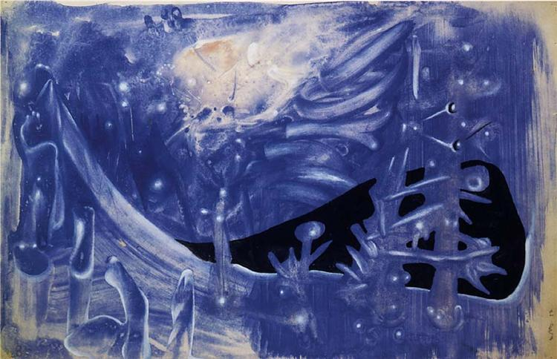

Blue Composition, (Composición Azul) 1937, oil on canvas.
32.5 x 50 cm

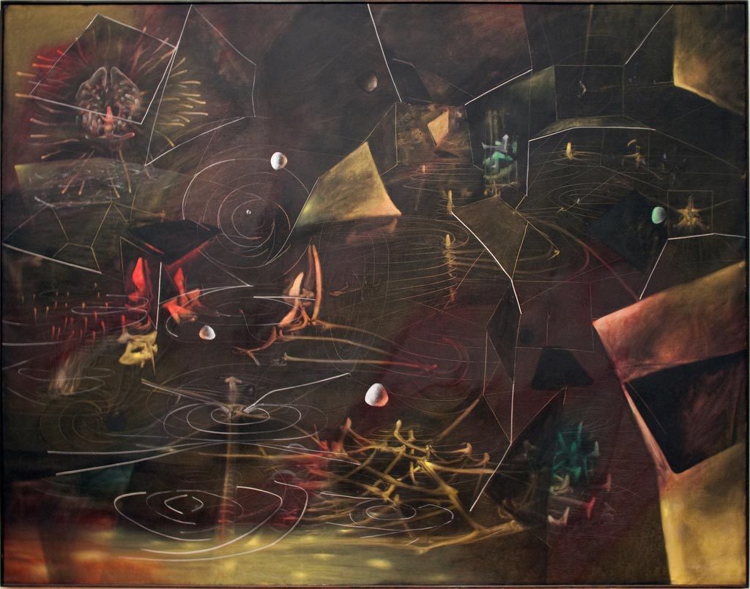

The Vertigo of Eros, 1944
Oil on canvas, 6' 5" x 8' 3
MoMA
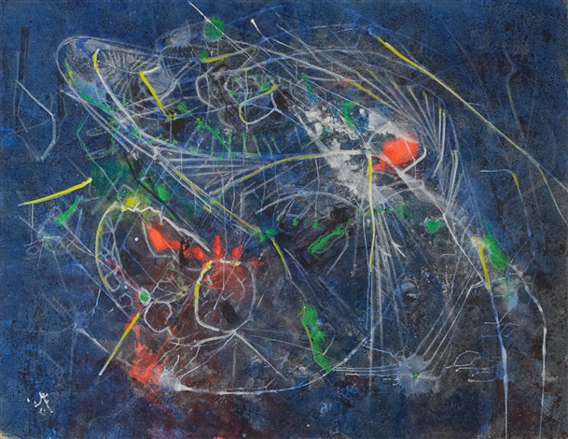
Le Coeur de l'oeil, 1999
Oil on canvas, 64.6 x 85 in.

